**Catch the Pizzas**

1. Add a backdrop from the Backdrop library (Wall 1).
2. Paint a Pizza sprite as a bitmap.

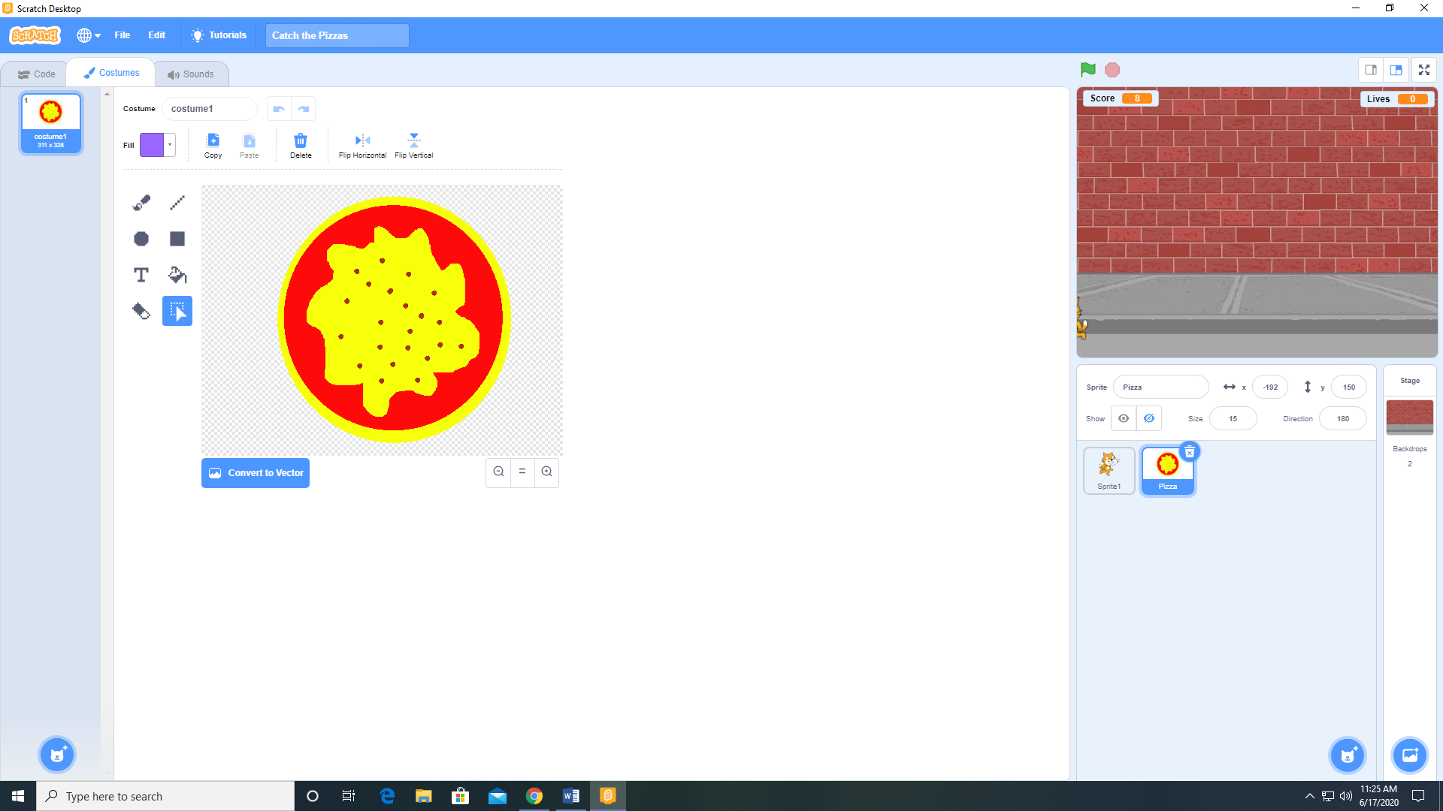

1. Create 3 variables Lives, Score, and Speed. Make Speed ”For this sprite only “ and the other two variables “For All Sprites”. Make Lives and Score visible on stage.
2. Add the Chomp sound to the Pizza sprite from the sound library.
3. Add the following code to the Pizza sprite.

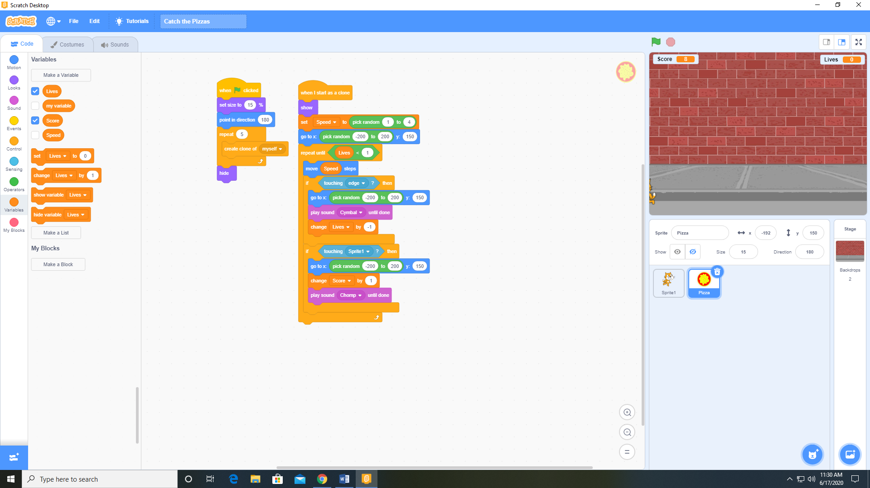

1. Add the Meow sound to the Sprite 1 (the cat) from the sound library.
2. Add the following code to Sprite 1 (the cat).

